Lady Macbeth Seizing the Daggers 1812
Henry Fuseli
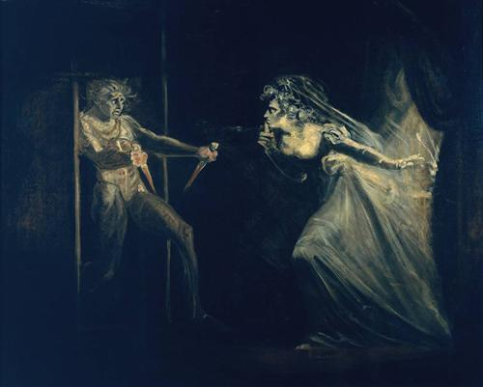

This artwork is in the public domain.

